**Web and Internet**

**Class Six**

**Lab 7**

|  |
| --- |
| Lab Objectives:  * Client * Server * Host * Media * IP Address |

## In this section, we’re going to define the relationship of client, server, and host computers according to your home network environment.

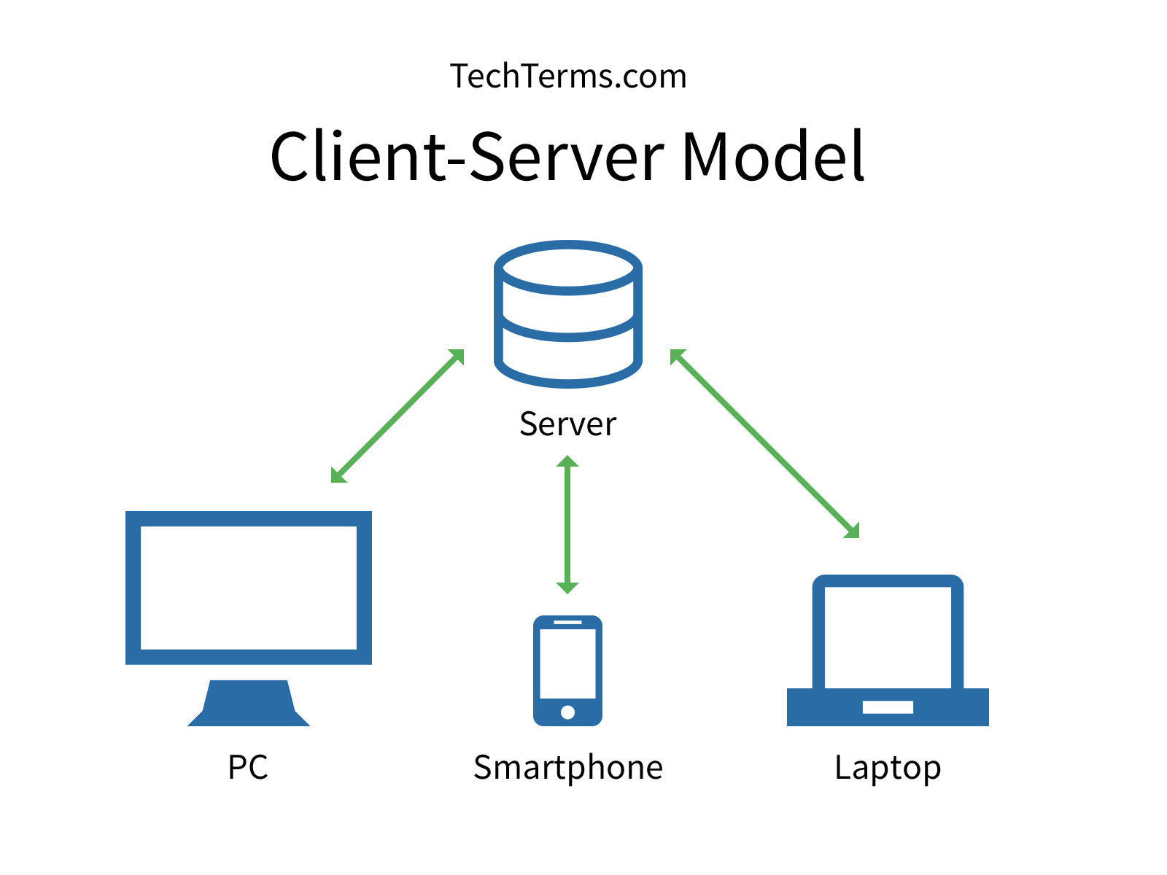

# What is a Client?

## A client is a computer hardware device or software that accesses a service made available by a server. The server is often (but not always) located on a separate physical computer.

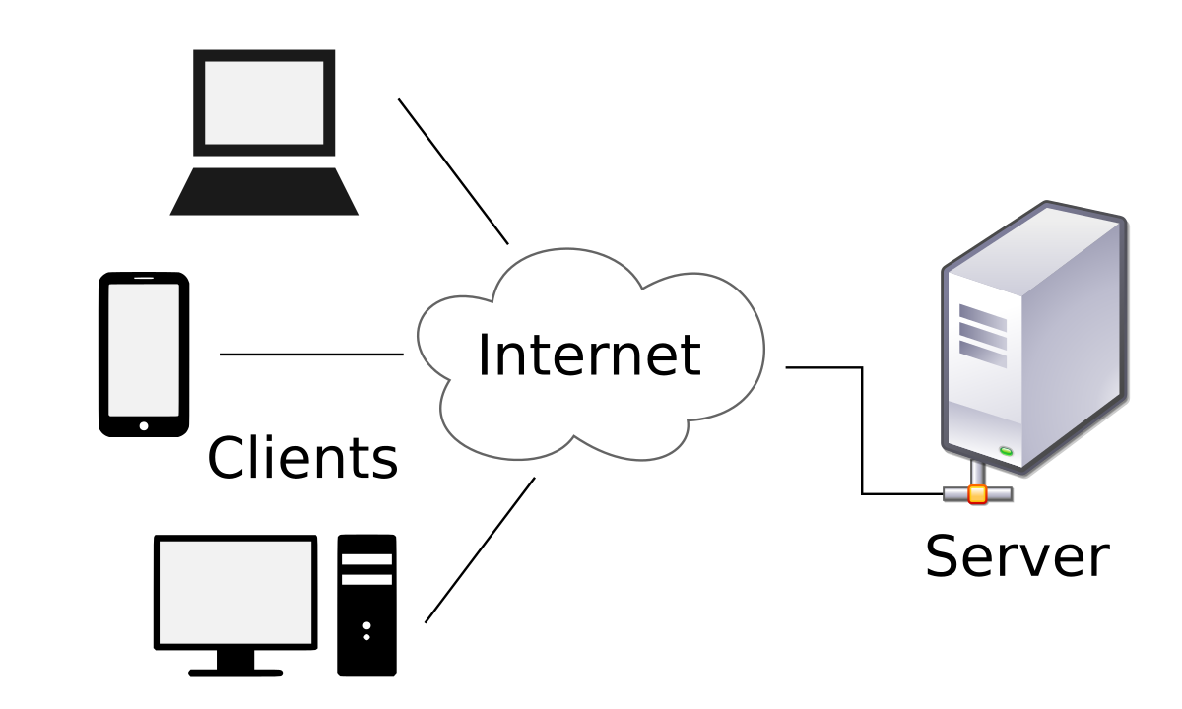

# What is a Server?

## A server is a physical computer dedicated to run services to serve the needs of other computers. Depending on the service that is running, it could be a file server, database server, home media server, print server, or web server.

# What is a Host?

## A host is a computer, connected to other computers for which it provides data or services over a network.

## In theory, every computer connected to a network acts as a host to other peers on the network. In essence, a host reflects the logical relationship of two or more computers on a network.

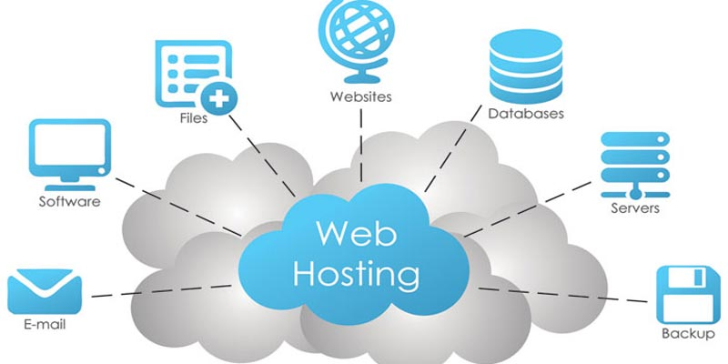

# IMG_256

# What is Media?

## Media refers to the communication channels used to interconnect nodes on a computer network.

## Typical examples of network media include copper coaxial cable, copper twisted pair cables and optical fiber cables used in wired networks, and radio waves used in wireless data communications networks.

# What is IP Address?

## An Internet Protocol address is a numerical label assigned to each device connected to a computer network that uses the Internet Protocol for communication.



In every IP address there are network ID and host ID

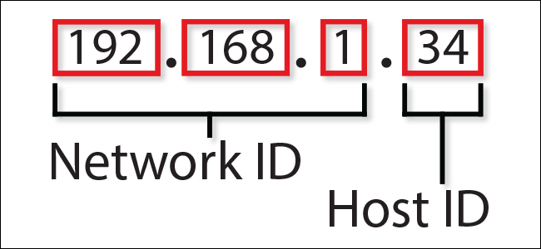

IP Address can be public or private. Public IP is unique whether private/local IP may not be unique.

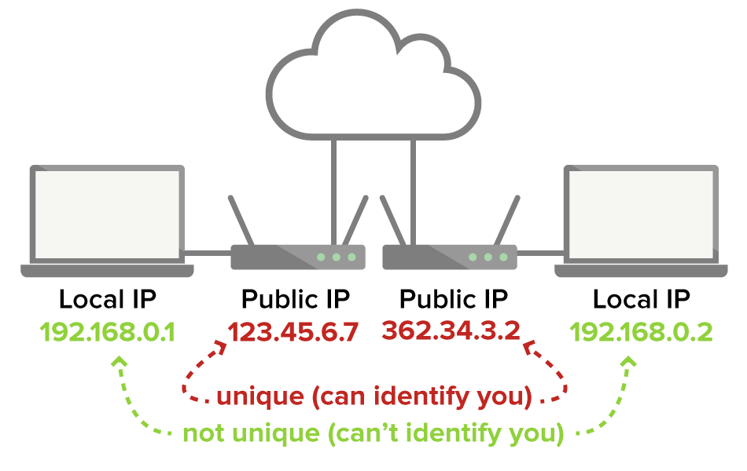

# How do you access a server?

## A server can be located inside or outside of your LAN. Accessibility to the server is determined by whether or not it has a public IP address or private IP address. If the server has a public IP address, it can be accessed from the web.

## IMG_256

## If it has a private IP address, it can only be accessed from inside of your LAN

# What is the difference between a server and a host?

### A server:

## Can be a physical device or software program

## Installed on a host computer

## Provides specific services

## Serves only clients

### A host:

## Is always a physical computer or device

## Can run both server and client programs

## Provides specific services

## Serves multiple users and devices

# The application layer

## In network applications, a client and server work together to get useful work done.

Clients and servers communicate with each other across the Internet or any other network.

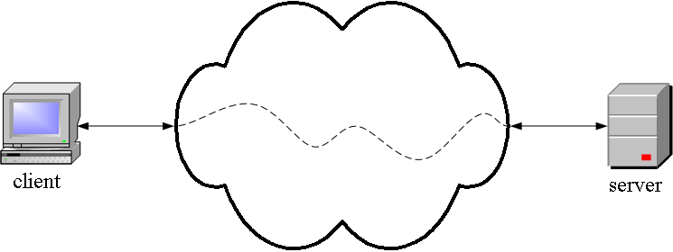

## The Web is a familiar client-server application.To see a Web page, you run a Web client like Firefox.

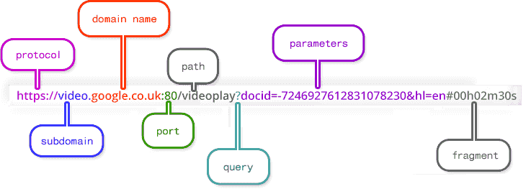

## IMG_256When you enter a URL and hit enter, the client encloses it in a Get message which it sends across the network to a Web server.

## IMG_256If the document is on that Web server, it sends it back to the client. If not, it sends an error message (formatted as a Web page). When the client receives the page (pr error message), it formats and displays it.

## This dialog between the client and the server follows a specific pattern or protocol. The protocol specifies the format of messages that can be sent and their meanings. The Web protocol is called the Hypertext Transfer Protocol (HTTP).



## Surfing the Web with a Web client is a popular application, but there are many other application protocols, for example:

|  |  |
| --- | --- |
| **Protocol** | **Application** |
| HTTP, Hypertext Transfer | retrieving and viewing Web pages |
| FTP, File Transfer | copy files from client to server or from server to client |
| SMTP, Simple Mail Transport | Send email |
| POP, Post Office | Read email |